1. **Features/Functionality that are in scope from interface perspective**

**The purpose of implementing this interface to push data from storage to Hadoop clusters using Azure Synapse Analytics workspace and SAP HANA.**

**Benefits of Microsoft d365 with Microsoft Azure:**

Both D365 and Azure are from Microsoft so that they can work well with each other.

Microsoft Azure can improve your Dynamics 365 applications significantly by providing a perfect setting to create, deploy and manage applications.

1. **Updated architecture diagram**

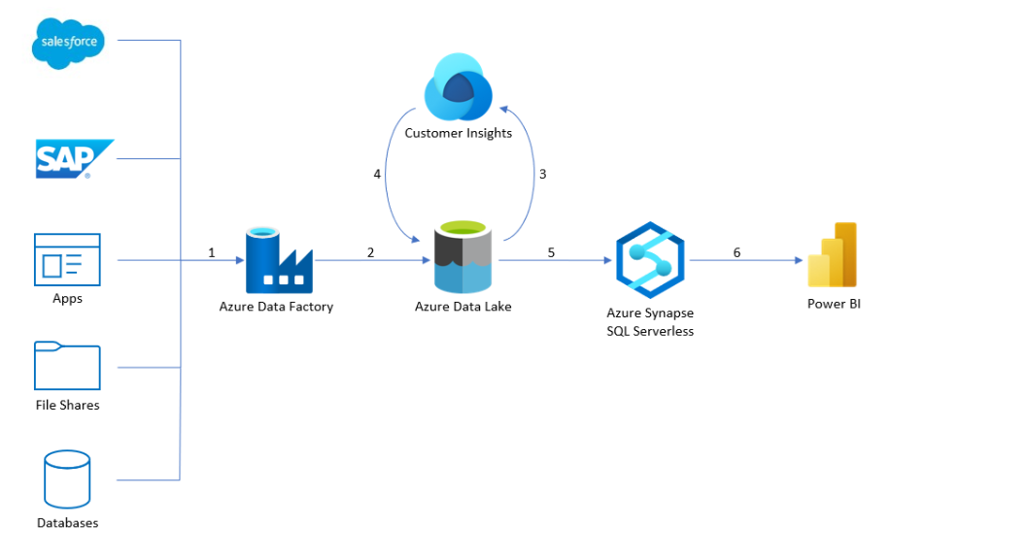

**Fig. 1 Architecture Diagram**

1. **UI Screens**

**Storage Account for ADLS:**

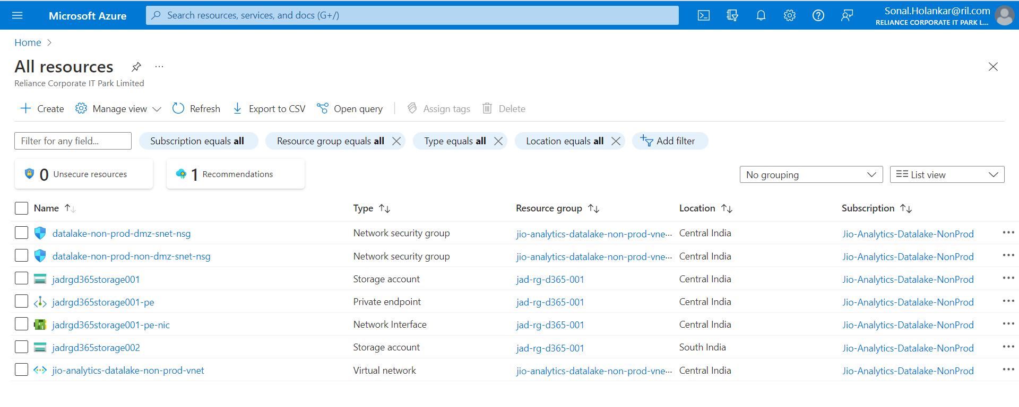

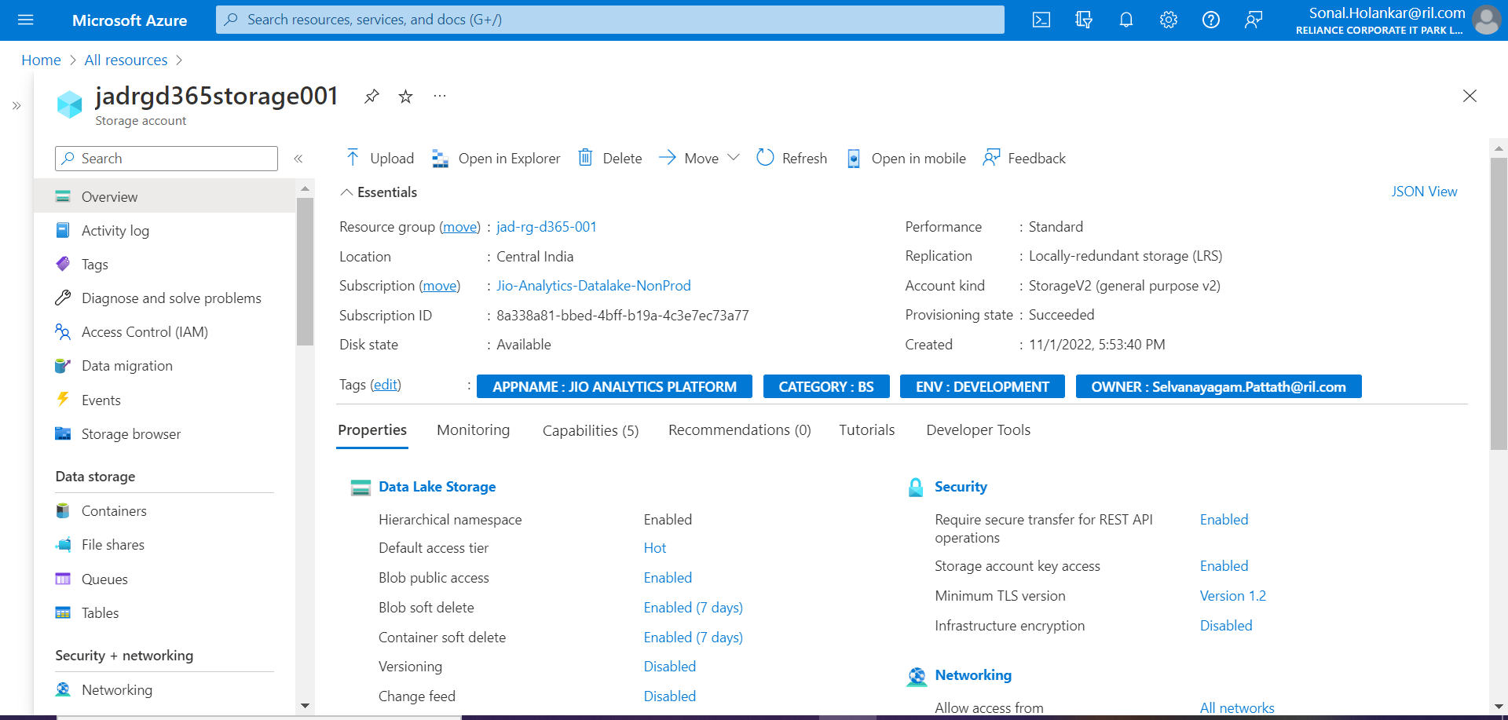

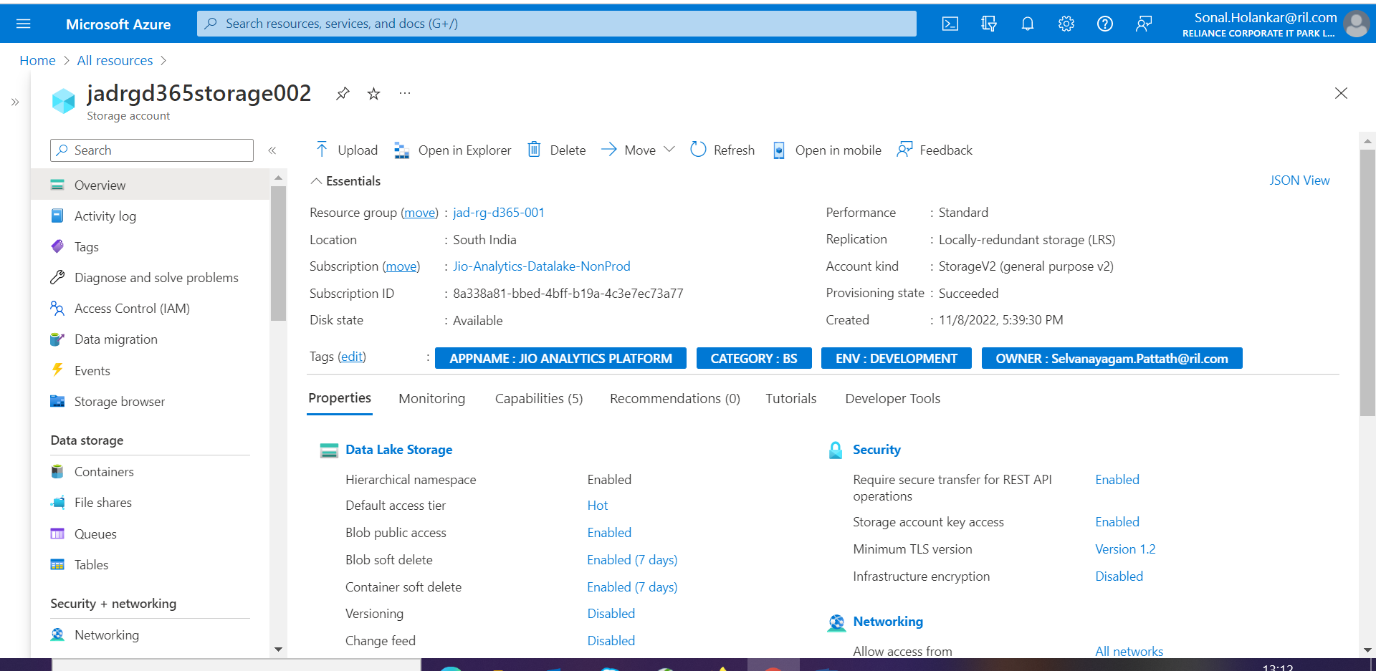

**ADLS to Azure Synapse Workspace:**

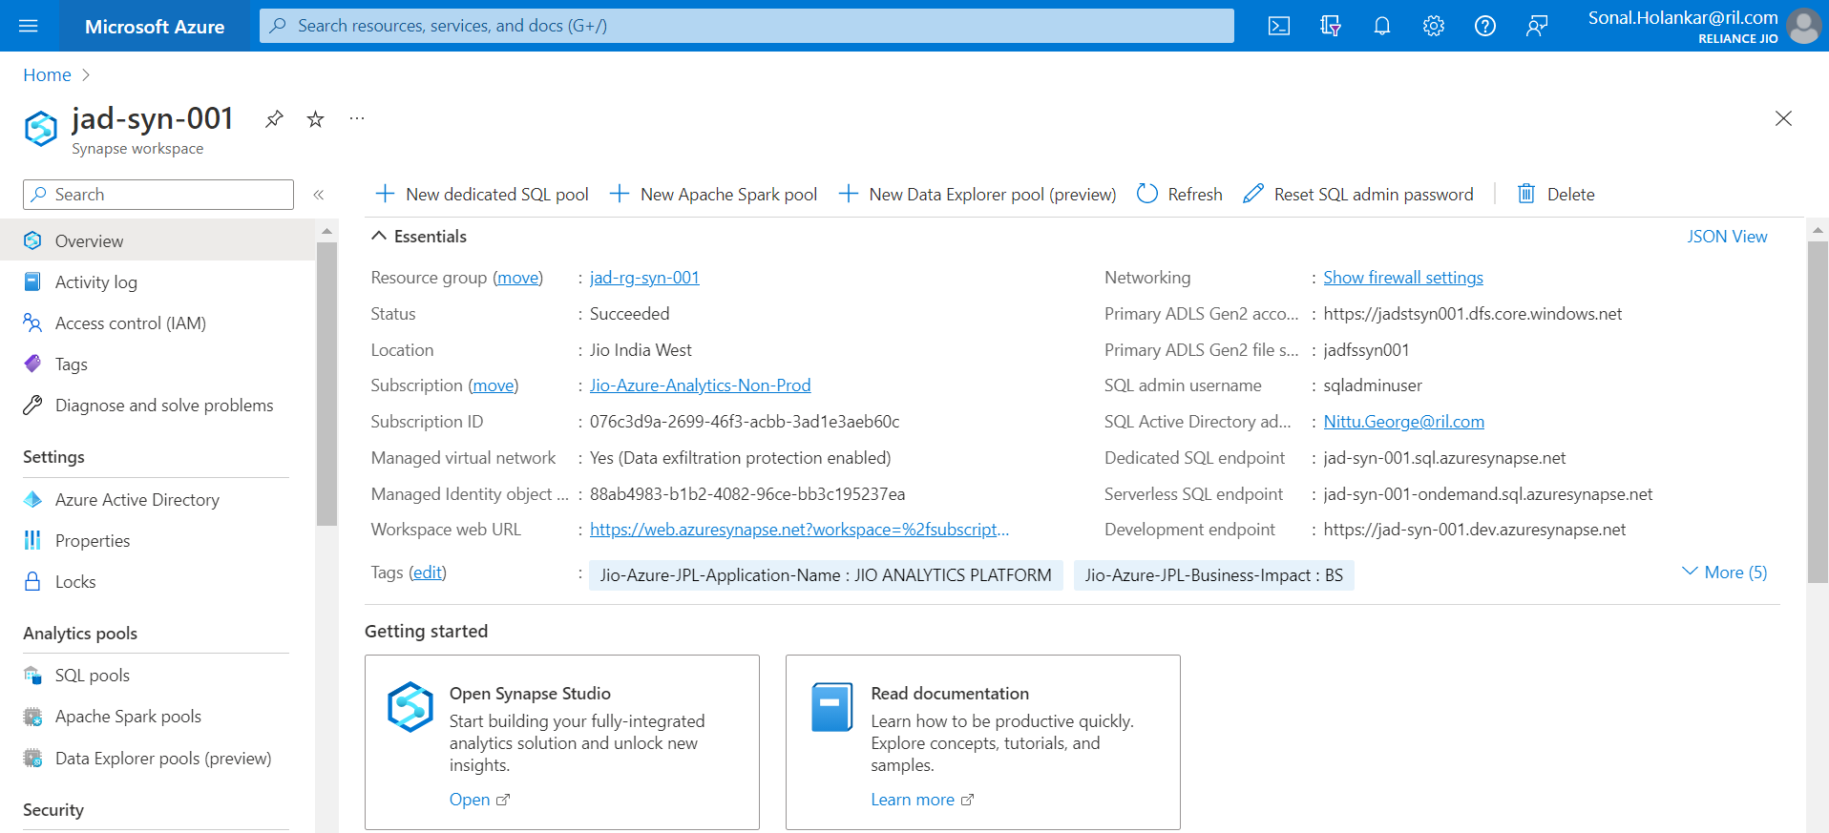

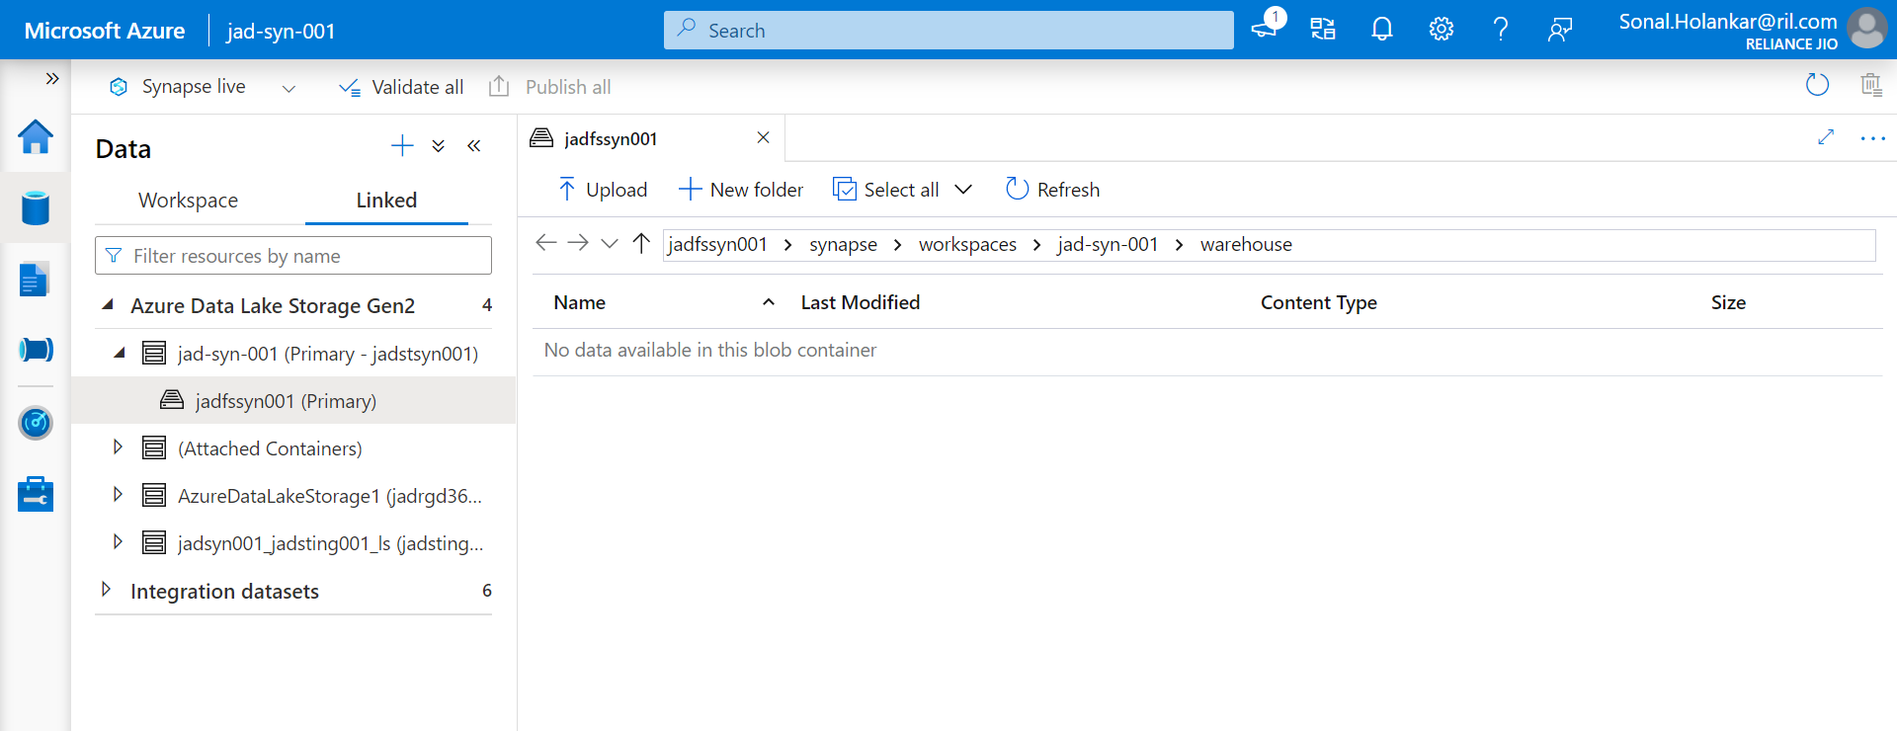

**Azure Synapse to SAP HANA:**

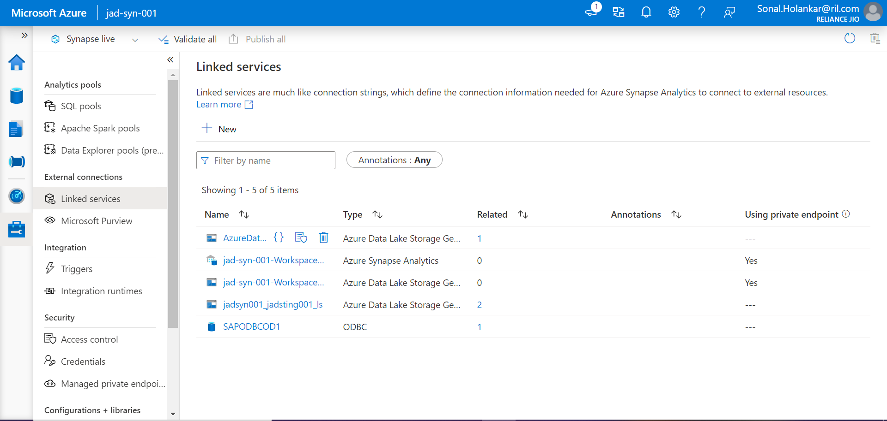

1. **Sample file of the content that will be ingested**

File Name: Leads.csv

1. **List of user roles along with the access matrix**

Azure Active Directory Admin and Users

1. **Process for on boarding/off boarding users in the application**

On-boarding Users: The users which are uses the services and resources of Azure portal.

Off-boarding Users: The users which gives access to another users on Azure portal.

Example: Azure Portal Admin

1. **Any user activity logs implemented while performing actions in tool? If yes, please share the details for the same**

Please check activity logs using below paths:

Azure Portal -> Azure Synapse Analytics -> jad-syn-001 -> Activity Log

1. **Sample excel file (available as a part of downloading)**

File Name: Leads.csv

1. **Any data shared outside India? If yes, please share the business requirement for the same**

NO.

1. **Details of cloud account (FQDN and namespace)**

Storage Account Name: Jadrgd365storage001 Region: Central India

Storage Account Name: Jadrgd365storage001 Region: South India

1. **Location/region of Azure data lake**

Please check below path:

Azure Portal -> Azure Synapse Analytics Studio -> jad-syn-001 -> Linked Services -> Azure DataLake StorageGen2

1. **Retention period for storing details in azure data lake**

Retention period: 3 Years

1. **Is any DR plan implemented for Azure Data Lake? If yes, please share the details for the same**

Yes. Data Lake Storage Gen1 provides locally redundant storage (LRS). Therefore, the data in your Data Lake Storage Gen1 account is resilient to transient hardware failures within a data center through automated replicas.

1. **Any security control implemented while storing the details in Azure Data Lake?**

Access Control (IAM – Identity Access Management) can provide security by giving specific roles to the user. For example:

Owner: It gives access to manage all resources, including ability to assign roles in RBAC.

Contributor: It gives access to manage all resources but does not give ability to assign roles in RBAC.

1. **Authentication mechanism to access the data that is stored in Azure data lake**

Account key (Storage Account Key) authentication mechanism is implemented.

1. **Any Citrix required to access the interface? If yes, please share the Citrix details**

NO.

1. **Is there any direct user access available on the data stored in Azure Data Lake? If yes, kindly share the business requirement for the same**

NO.

1. **Any security control implemented while storing the details in HANA?**

Access Control (IAM – Identity Access Management) can provide security by giving specific roles to the user. For example:

Owner: It gives access to manage all resources, including ability to assign roles in RBAC.

Contributor: It gives access to manage all resources but does not give ability to assign roles in RBAC.

1. **Retention period for storing details in HANA**

Retention period: 1 Year